Project Title

**Hostel Attendance Management System**

Submitted by

Mr. Ganesh Vitthal Karande

Roll No:- 205223013

Data Analytics

**Problem Statement:**

Manual hostel attendance management is error-prone, time-consuming, and lacks real-time monitoring. This project addresses these issues by developing a secure, automated Hostel Attendance Management System. It aims to eliminate errors, save time, ensure data accuracy, and enhance communication between administrators, residents, and their guardians, revolutionizing hostel attendance tracking.

**Database Schema for the Project:**

1. Admin Table:

UserID (Primary Key)

firstName

lastName

emailAddress

Password



2)Students Table:

StudentID (Primary Key)

FirstName

LastName

RollNumber

Batch

ContactNumber

Email

GuardianName

GuardianContact



3)Attendance Table:

AttendanceID (Primary Key)

StudentID (Foreign Key referencing Students.StudentID)

Date

Status (Present, Absent, Late, Excused, etc.)



**ER Diagram:**

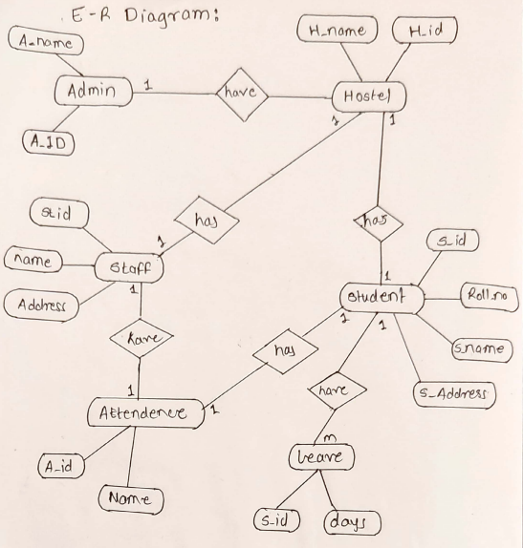

**List of Stakeholders for the project:**

1. Hostel Administrators:
2. Hostel Staff:
3. Students:.

**Database type used :**

Relational Database (MySQL)

**Screenshots of front end developed for the views of stakeholders:**

**1)Login Page**

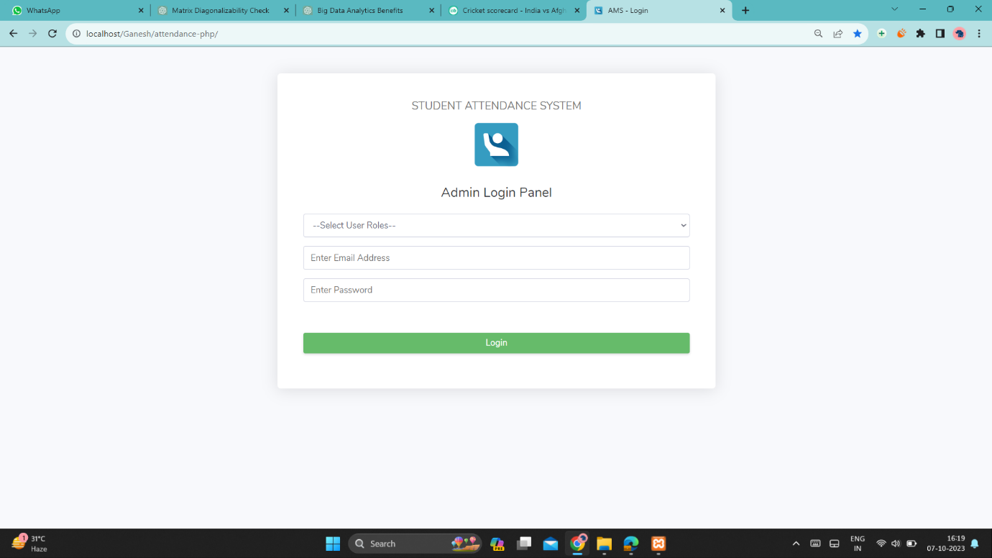

**2)Admin Page:**

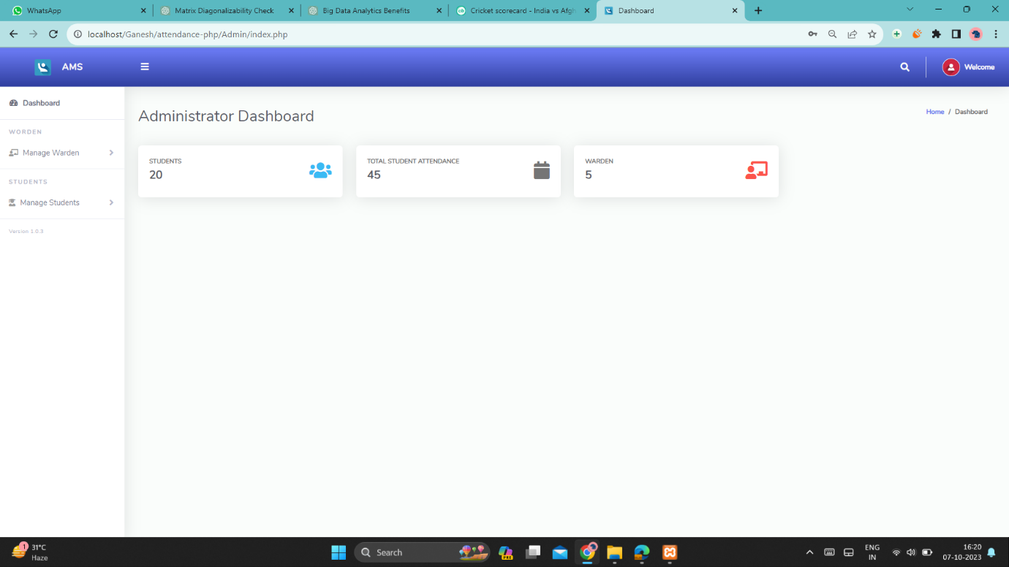

**2)Warden Page:** 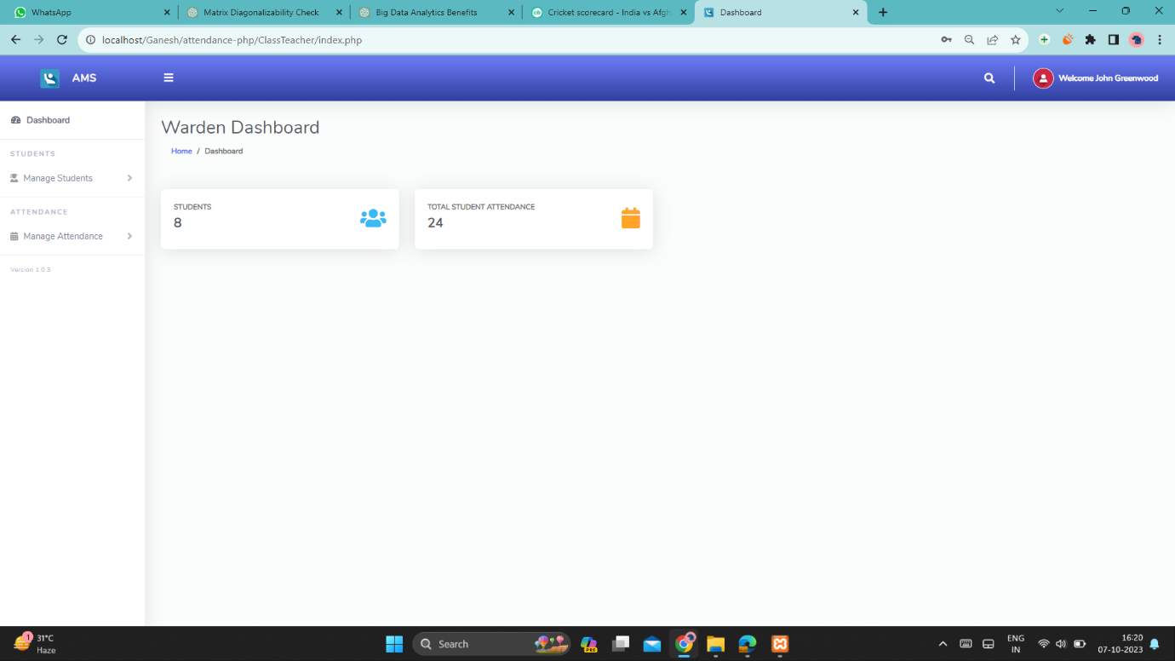

**3)Student Page:**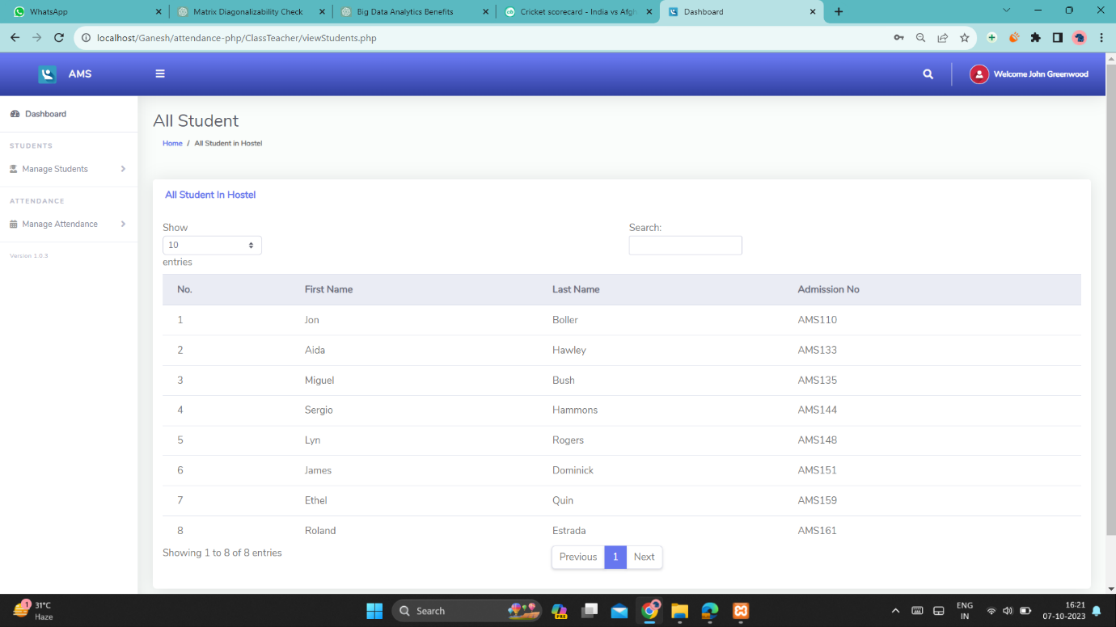

**4) Attendence Page:**